**NIST Technical Note 1908**

**The Use of Demand-to-Capacity Indexes for the Iterative Design of Rigid Structures for Wind**

Filmon Habte

Arindam Gan Chowdhury

Sejun Park

This publication is available free of charge from:

http://dx.doi.org/10.6028/NIST.TN.1908



**NIST Technical Note 1908**

**The Use of Demand-to-Capacity Indexes for the Iterative Design of Rigid Structures for Wind**

Filmon Habte

Arindam Gan Chowdhury

*Department of Civil and Environmental Engineering*

*Florida International University, Miami, Florida*

Sejun Park

*Engineering Laboratory*

*National Institute of Standards and Technology*

*Gaithersburg, MD 20899-7311*

This publication is available free of charge from:

http://dx.doi.org/10.6028/NIST.TN.1908

January 2016



U.S. Department of Commerce

*Penny Pritzker, Secretary*

National Institute of Standards and Technology

*Willie May, Under Secretary of Commerce for Standards and Technology and Director*

Certain commercial entities, equipment, or materials may be identified in this

document in order to describe an experimental procedure or concept adequately.

Such identification is not intended to imply recommendation or endorsement by the

National Institute of Standards and Technology, nor is it intended to imply that the

entities, materials, or equipment are necessarily the best available for the purpose.

**National Institute of Standards and Technology Technical Note 1908**

**Natl. Inst. Stand. Technol. Tech. Note 1908, 44 pages (January 2016)**

**CODEN: NTNOEF**

**This publication is available free of charge from:**

**http://dx.doi.org/10.6028/NIST.TN.1908**

Disclaimers

(1) The policy of the NIST is to use the International System of Units in its technical communications. In this document however, works of authors outside NIST are cited which describe measurements in certain non-SI units. Thus, it is more practical to include the non-SI unit measurements from these references.

(2) Certain trade names or company products or procedures may be mentioned in the text to specify adequately the experimental procedure or equipment used. In no case does such identification imply recommendation or endorsement by the National Institute of Standards and Technology, nor does it imply that the products or procedures are the best available for the purpose.

Abstract

Estimates of wind effects on rigid buildings by database-assisted design (DAD) methods can be more accurate than those based on information available in standards. An upgraded version of DAD was developed that streamlines the wind engineering/structural engineering components of the design process by allowing the direct computation of Demand-to-Capacity Indexes (DCIs).

Although the basic procedure described in this report is applicable to any rigid building, the focus in this work is on simple buildings with gable roofs, portal frames, and bracing parallel to the ridge. The procedure makes use of the two largest building aerodynamics databases available worldwide; large simulated extreme wind databases for hurricane- and non-hurricane-prone regions; a novel interpolation scheme allowing the design of buildings with dimensions not covered in the databases; an effective multiple-points-in-time algorithm for estimating peaks; and parameter-free methods for estimating DCIs with specified mean recurrence intervals. In addition to a brief description of the procedure, the report contains the following link to the software developed for the implementation of the procedure: [www.nist.gov/wind/DADmetalportalframes](http://www.nist.gov/wind/DADmetalportalframes). A user’s manual for the software is also included in this report.

**Keywords**: Aerodynamics; database-assisted design; demand-to-capacity indexes; parameter-free statistics; structural engineering; wind climatology; wind engineering.

Acknowledgment

Contributions to this report by D. Yeo, helpful comments and assistance by Joseph A. Main, E. Simiu, and N. A. Heckert, and careful review by Prof. Yongwook Kim of the Manhattan College are acknowledged with thanks. Filmon Habte gratefully acknowledges the scholarship support provided by the Presidential Fellowship (Florida International University, Graduate School). Sejun Park served as a Guest Researcher at the Engineering Laboratory of the National Institute of Standards and Technology; on leave from the School of Civil and Environmental Engineering, Yonsei University, Seoul, South Korea.

Contents

[**Abstract**.. i](#_Toc429763199)

[**Acknowledgment** ii](#_Toc429763213)

[**Contents** iii](#_Toc429763200)

[**List of Figures** iv](#_Toc429763201)

[**List of Tables** v](#_Toc429763202)

[1.  **Description of the Iterative Design Procedure**](#_Toc429763203)

- *Filmon Habte and Arindam Gan Chowdhury*

[1.1. Introduction 6](#_Toc429763204)

[1.2. Description of the Structural System 7](#_Toc429763205)

[1.3. Overview of the Design Procedure 8](#_Toc429763206)

[1.4. Aerodynamic and Wind Climatological Databases 10](#_Toc429763207)

[1.5. Internal Forces and Deflections Induced By Wind with Unit Speed at Eave Height 10](#_Toc429763208)

[1.6. DCI Databases 12](#_Toc429763209)

[1.7. Estimation of Peak DCIs and Deflections with Specified MRIs. 13](#_Toc429763210)

[1.8. Interpolation Procedures 14](#_Toc429763211)

[Conclusions 16](#_Toc429763212)

[References 17](#_Toc429763214)

[2. **USER’S MANUAL**](#_Toc429763215)

- *Filmon Habte and Sejun Park*

[2.1. Description of the Graphical User Interface (GUI) 18](#_Toc429763216)

[2.2. Building Input File 28](#_Toc429763217)

[2.3. Design Output File 29](#_Toc429763218)

[2.4. Design Example 31](#_Toc429763219)

[**APPENDIX** 35](#_Toc429763220)

List of Figures

[Figure 1. Structural System 8](#_Toc430110399)

[Figure 2: DCI database 13](#_Toc430110400)

[Figure 3: Frame Design Menu Page 18](#_Toc430110401)

[Figure 4: Enter Building Information 19](#_Toc430110402)

[Figure 5: Input Building Dimensions 19](#_Toc430110403)

[Figure 6: Input Terrain Conditions 20](#_Toc430110404)

[Figure 7: Input Frame Locations 20](#_Toc430110405)

[Figure 8: Definition of Frame Locations 20](#_Toc430110406)

[Figure 9: Input Attachment Locations 21](#_Toc430110407)

[Figure 10: Input Frame Supports 21](#_Toc430110408)

[Figure 11: Input Frame Design Parameters 21](#_Toc430110409)

[Figure 12: Input Cross-Section Design Parameters 22](#_Toc430110410)

[Figure 13: Input Gravity Loads 22](#_Toc430110411)

[Figure 14: Computation of Time-histories of Responses GUI 24](#_Toc430110412)

[Figure 15: Select Response Computation Options 24](#_Toc430110413)

[Figure 16: Input Sampling Rate Reduction 24](#_Toc430110414)

[Figure 17: Output of Time-series of Responses 25](#_Toc430110415)

[Figure 18: Design of Frames GUI 26](#_Toc430110416)

[Figure 19: Designed Frame Sections 27](#_Toc430110417)

[Figure 20: Sample Building Input File 28](#_Toc430110418)

[Figure 21: Definition of Attachment Locations 29](#_Toc430110419)

[Figure 22: Sample Design Output File 30](#_Toc430110420)

[Figure 23: Definition of Sections in the Design Output File 31](#_Toc430110421)

List of Tables

[Table 1: Enter Building Information 32](#_Toc437005126)

[Table 2: Input Design Parameters 32](#_Toc437005127)

[Table 3: Input Gravity Loads 33](#_Toc437005128)

[Table 4: Output of Designed Frame Sections 34](#_Toc437005129)

[Table A1: Variables of the *bldg\_struct* Data-structure 35](#_Toc437005130)

[Table A2: Variables of *TIF\_struct* Data-structure 38](#_Toc437005131)

[Table A3: Variables of the *DCI\_struct* Data-structure 39](#_Toc437005132)

# Description of the Iterative Design Procedure

*Filmon Habte and Arindam Gan Chowdhury*

## 1.1 Introduction

Conventional methods for determining wind loads on main wind force resisting systems (MWFRS) of rigid buildings involve the use of tables and plots provided in standards and codes (e.g., the Standard on Minimum Design Loads for Buildings and Other Structures [1]). The wind loads determined by such methods can differ from wind loads consistent with laboratory measurements by amounts found in some cases to exceed 50 % [2].

Increased computational power and major advances in pressure measurement capabilities led to the development of the database-assisted design (DAD) concept. DAD makes direct use of stored pressure time series to calculate wind loads [3]. One of DAD’s useful features is that it allows wind effect combinations to be performed objectively via simple algebraic time series summations. For example, internal forces in structural members are in general induced by wind loads that act in the directions of the two principal axes of the structure, *x* and *y*, and are therefore imperfectly correlated*.* Also, cross sections of the MWFRS are simultaneously acted upon by bending moments and axial forces that, typically, are also imperfectly correlated. The capability to perform rigorously correct combinations of wind effects distinguishes time-domain from frequency-domain techniques since, as typically used in wind engineering, the latter do not preserve phase relationships and therefore force designers to combine wind effects subjectively.

The application of the DAD approach to rigid structures has so far been developed primarily for frames of simple gable roof buildings [4]. A main purpose of the procedure presented in this report is to expand the capabilities of previous work by using time series of Demand-to-Capacity Indexes (DCIs, i.e., left-hand sides of the design interaction equation), for structural design purposes. As shown in subsequent sections, this eliminates or reduces inaccuracies in the representation of wind effects and can result in more effective designs. In spite of its focus on frames of simple gable roof buildings, the procedure can, with modest modifications, be adapted for use for any rigid buildings, including mid-rise buildings.

The procedure enables the use of the large, recently developed Tokyo Polytechnic University (TPU) database (<http://wind.arch.t-kougei.ac.jp/system/eng/contents/code/tpu>), which was shown in [5] to result in response estimates comparable to those based on the National Institute of Standards and Technology (NIST)/University of Western Ontario (UWO) database (<http://fris2.nist.gov/winddata>). This largely eliminates what, according to the Commentary to the ASCE 7-10 Standard, is an important obstacle to the wide use of DAD-based approach in engineering practice: the fact that the NIST/UWO database is not sufficiently comprehensive. In addition, an updated interpolation routine is included in the procedure, which makes it possible to apply the DAD approach to buildings with dimensions and/or roof slopes different from those covered in those databases.

Checking the adequacy of the cross section’s design consists of ascertaining that, subject to possible serviceability constraints, its DCI is close to and less than unity. If the DCI of a cross section does not satisfy this condition, the cross section must be redesigned. The structural member properties based on this iteration process may then be used to recalculate the requisite influence coefficients and perform checks based on those recalculated values.

Since different expressions for the DCI apply for different axial loads [see Equation (1)], the DCIs depend nonlinearly upon axial load. Therefore, the peak DCIs are not proportional to the squares of the wind speeds inducing them. Therefore, for the structure being designed, it is necessary to calculate sets of DCIs induced by winds with a sufficient number of directions and speeds by accounting for Equation (1). Those sets are referred to as DCI databases. The calculations of peak DCI databases use an economical multiple-points-in-time method developed in [6].

The peak DCI databases are the structure’s responses under wind and gravity loading that depend upon the structural system’s configuration, member sizes, and terrain exposure, and are independent of the wind climate. The databases are used to estimate peak DCIs with any specified mean recurrence intervals (MRIs) by using non-parametric statistics. Since the design MRIs specified in [1] are of the order of hundreds or thousands of years, the use of such statistics requires that the directional wind speed database be commensurately large. With a view to expanding the usefulness of the DAD approach to structural designers, a procedure for developing large extratropical wind speed databases was developed by Yeo [7], thus eliminating an earlier restriction of wind climatological databases to hurricane data.

The software for the implementation of the procedure is available at <http://www.itl.nit.gov/div898/winds/iterative_design/wind_pressure.htm> and <http://www.nist.gov/el>.

## 1.2 Description of the Structural System

The MWFRS being considered consists of equally spaced moment-resisting steel portal frames (with compact flange and web elements) spanning the width of the building (Figure 1). Portal frames are the most commonly used structural forms in low-rise industrial buildings, and are typically designed using web-tapered members. Roof and wall panels form the exterior envelope of the buildings, and are attached to purlins and girts supported by the frames.

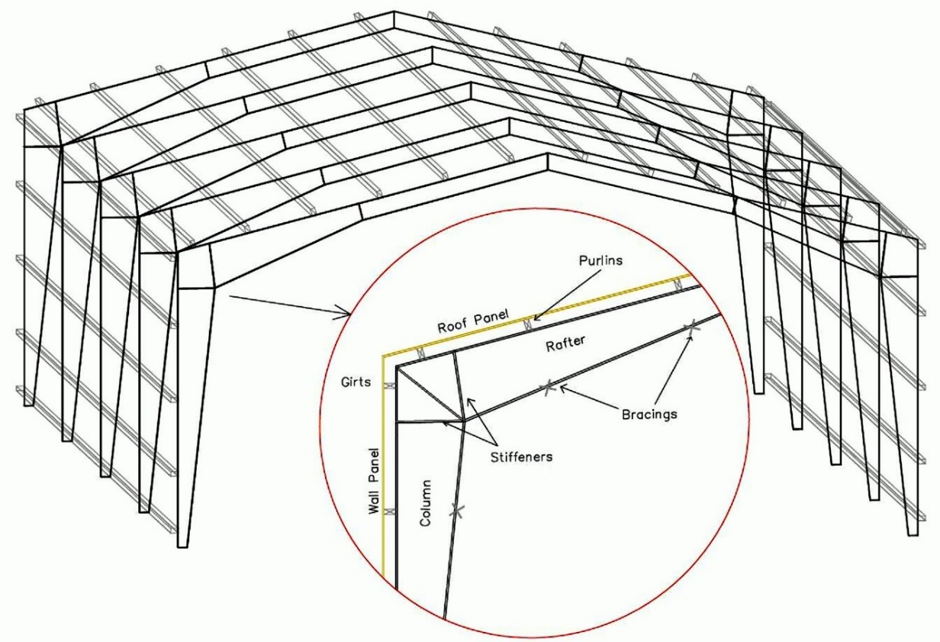

Figure 1. Structural System

The DAD procedure is based on the following assumptions: (1) bracing is provided in the planes of the exterior walls parallel to the ridge, hence responses to loads in that direction are not considered, (2) the coupling between frames due to the roof diaphragms is neglected, (3) the purlins and girts are attached to the frames by hinges, (4) the purlins and girts act as bracings to the outer flanges, and the inner flanges are also braced. The following limitations are imposed: (1) The taper should be linear or piecewise linear, and (2) the taper slope should typically not exceed 15o [8].

## 1.3 Overview of the Design Procedure

The sizing of the structural members is accomplished via the calculation of their DCIs. The final design is achieved when the member DCIs are less than and as close as possible to unity, to within specified serviceability and constructability constraints. The calculation of the DCIs makes use of the procedures for determining member capacities specified in the American Institute of Steel Construction Manual [9] and Steel Design Guide 25: Frame Design Using Web-Tapered Members [8]. Preliminary investigation of the stability of the frame members showed that secondary moments have typically negligible effects on the type of structure being considered. However, in order to comply with the AISC’s design for stability requirements, a first order analysis method of design was followed. This method, which accounts for geometric imperfections, requires that the total member moments be multiplied by an amplifier B1, and that lateral notional loads be applied in every loading combination. A brief explanation on how the first order analysis method was applied is provided in the Appendix. The frame members’ elastic in-plane buckling capacity, which is required for computing the axial capacity of the frame cross-sections, *Pij*, where the subscripts *i* and *j* identify the frame and the cross section, respectively, is computed using the method of successive approximations as described in Timoshenko and Gere [10]. The in-plane and out-of-plane buckling capacities were compared and the critical ones were selected for calculating the axial capacity of the frame cross sections.

For a given member cross section of a frame subjected to wind loading the DCI is a function of the internal forces. Each internal force is in turn a sum of contributions due to gravity loads and to wind forces acting along the building’s principal axes. In the particular case of the type of structure addressed here the wind forces acting along the axis parallel to the ridge are resisted by secondary bracing members; hence the wind force contributions to the DCIs are due only to forces normal to the building’s ridge. Time series of DCIs pertaining to axial forces and bending moments at cross section *j* of frame *i*, denoted by DCI*ijPM* (*t*)*,* have the expressions

  (1)

 

where *Prij(t)* and *MrijX(t)* are time histories of total axial load and in-plane bending moment respectively; *Pij* and *Mij*  are the nominal axial and in-plane flexural strengths of the cross-section;and are axial and flexural resistance factors, respectively. The demand-to-capacity index for shear forces, *DCIijV* (*t*) at cross section *j* of frame *i* is computed as follows

 (2)

where *Srij (t)* denotes the time history of the total shear load, *Sij* is the nominal shear strength of cross-section *j* of frame *i*, and is the resistance factor for shear forces. The force time histories in Eqs. (1) and (2) are computed as sums of factored load effects due to gravity (which are assumed to be constant in time) and wind loads (which are time-varying). Equations (1) maintain the phase relationship between the different load effects (i.e., axial and bending moments), hence they produce DCIs rigorously commensurate with the actual combined wind effects.

The preliminary design must start with an informed guess as to the MWFRS’s member sizes (i.e., with a preliminary design denoted by *Des*0), to which there corresponds a set of influence coefficients denoted by *IC*0. The wind loads applied to this preliminary design are taken from the standard or code being used. In the case of portal frames on which this paper is focused, the ASCE 7-10 Standard wind loads can be taken from the Standard’s Chapter 27 or Chapter 28.

The next step is the calculation of the DCIs inherent in the design *Des*0. The cross sections are then modified so that their DCIs are close to unity. This results in a new design, *Des*1, for which the corresponding set of influence coefficients, *IC*1, and a new set of DCIs are calculated. The procedure is repeated until a design *Desn* is achieved such that the effect of using a new set of influence coefficients, *ICn*+1, is negligible, that is, until the design *Desn*+1is in practice identical to the design *Desn*. Next, the procedure is repeated by using, instead of the Standard wind loads, the loads based on the time histories of the pressure coefficients taken from the aerodynamics database. This results in a design *Desn*+2, to which there corresponds a set of influence coefficients *ICn*+2 and a new set of DCIs. The cross sections are then modified so that the DCIs are close to and less than unity. Typically this will be the final design *Desfinal*, although the user may perform an additional iteration to check that convergence of the DCIs to unity has been achieved, to within constructability and serviceability constraints.

## 1.4 Aerodynamic and Wind Climatological Databases

Aerodynamic databases provide the spatio-temporal distribution of wind pressures on building surfaces for various wind directions and terrain conditions. They are typically obtained from pressures measured in wind tunnels at large numbers of ports on the external and/or internal surface of building models. As mentioned earlier, the aerodynamic databases used here are: (1) the NIST/UWO database (<http://fris2.nist.gov/winddata/>), and (2) the Tokyo Polytechnic University (TPU) aerodynamics database (<http://wind.arch.t-kougei.ac.jp/system/eng/contents/code/tpu>). To the authors’ knowledge, these are currently the two largest public aerodynamic databases.

Climatological databases typically consist of matrices of recorded or simulated extreme wind speeds versus their directions for different locations of interest. The climatological database used in this work consisted of estimates of largest hurricane wind speeds generated in [11] using Monte Carlo simulations for 16 wind directions and 999 storm events simulated for a large number of locations along the Gulf of Mexico and North Atlantic coast (<http://www.nist.gov/wind>). For regions not prone to hurricanes large directional climatological databases required for the estimation of wind effects with 300-yr to 3,000-yr MRIs can be simulated from available directional wind speed data available on the same site, as shown in [7].

## 1.5 Internal Forces and Deflections Induced By Wind with Unit Speed at Eave Height

The assumptions and procedures followed in transferring wind loading from pressure taps on the exterior building surfaces to structural frames are similar to those used in [4], which contains detailed descriptions and explanations. The time series of the wind-induced internal forces *rwij* (*t,θ*) at cross section *j* of frame *i*, due to a unit wind speed with direction θ at eave height H, is

 (3)

where *ρ* is air density; *Nkij* is the influence coefficient representing the internal force at cross section *j*of frame *i*,due to a unit force applied at the *k-*th point of attachment of a purlin or girt to the frame *i*; and *Ak*represents the tributary area of the *k-*thpoint; *CkP*(*t,θ*) is the pressure coefficient applicable at the *k-*th attachment point, associated with a wind speed with direction *θ* at height *H*, calculated as the weighted average of pressure coefficients at taps located inside the area *Ak*; and *n* is the number attachment points on frame *i*.

For rigid structures, the wind-induced internal forces are proportional to the square of the wind speeds. Therefore, the time-series of total internal forces due to gravity and wind loads induced by wind with velocity *VH,θ* from direction *θ* at height *H* are

 (4)

where *rgij* is the internal force at cross-section *j* in frame *i* due to gravity loads; and *fg* and *fw* are load combination factors for gravity and wind loads, respectively. *Rij (t,θ)* represents any of the forces in the numerators of Eq. (1) and (2).

Strength design requires considering the following five LRFD load combination cases [1]:

Case 1: 1.4D,

Case 2: 1.2D + 0.5Lr,

Case 3: 1.2D + 1.6Lr + 0.5W,

Case 4: 1.2D + 1.0W +0.5Lr,

Case 5: 0.9D + 1.0W,

where D, Lr, and W denote dead load, roof live load and wind load, respectively. The dead load includes both superimposed dead load and frame self-weight. The superimposed dead load and roof live load are assumed to be uniformly distributed on the roof surface; they impose forces on the frame through the frame-purlin connections in the vertical downward direction. Self-weights are determined by dividing the frames into large number of elements.

Once time histories of total individual internal forces are determined, the estimation of combined internal forces associated with the axial forces and bending moments required for DCI calculations is performed using the multiple points-in-time (MPIT) approach for estimating peak wind effects [6]. In this approach the largest *n* local peaks (in absolute value) from the time series of each force or moment are selected first. Next the ordinates at the times of occurrence of those *n* peaks are selected in each of the *m –* 1 time series to be combined with that force or moment, where *m* is the total number of time series being combined. The combination of internal forces is then performed only for the *m* x *n* points so selected, rather than for the whole length of the time series. The estimated peak of the combined effects is then computed as the largest of the *m* x *n* combinations. This method significantly reduces the amount of computation required. Comparisons of DCIs computed using the entire time-histories of axial and bending moments to those calculated using the MPIT method with *n* = 20 showed that the MPIT approach produces highly accurate results [6].

Deflections can be calculated using Eq. 3 in which *Nkij* denotes the influence coefficient representing the deflection at cross section *j*of frame *i*,due to a unit force applied at the *k-*th point of attachment of a purlin or girt to the frame *i*.

## 1.6 DCI Databases

DCI databases are properties of the structure that incorporate its aerodynamic and mechanical characteristics at all cross sections of interest, and are independent of the wind climate. For rigid structures a DCI database for a member cross section consists of peak DCIs corresponding, for each of the incremental wind directions considered, to incremental wind speeds within a range that encompasses all speeds of interest. Note that, for member cross sections in compression, the DCI induced by a wind speed V is not proportional to the square of that wind speed. This is due to the dependence of the axial load capacity *Pij* upon the buckling effects associated with the applied axial load.

DCI databases are calculated for specified cross sections of all members being designed for all the loading combination cases being considered. Loading combinations 1 and 2 include dead and live loads only, hence response databases need not be prepared for those combinations. However, for each of the remaining loading combinations two sets of response databases are computed, one for positive and one for negative internal pressures. Effects of wind-induced positive and negative internal pressures are computed using internal pressure coefficients specified by the ASCE 7-10 for enclosed, partially enclosed, or open buildings.

Figure 2 shows the DCI database associated with the axial force and bending moment acting on the pinch cross section of the first interior frame in a building with the following dimensions: width *B* = 24.4 m (80 ft), length *L* = 38.1 m (125 ft), eave height *H* = 7.3 m (24 ft), roof slope = 4.8 deg. Frame spacing of 7.62 m (25 ft) was used and the DCI database plot shown is for loading combination 0.9D + 1.0W.

C:\Users\fhabt003\Dropbox\DCI\DCI_JOURNAL PAPER\figures\final\database_4.tif

Figure 2: DCI database

## 1.7 Estimation of Peak DCIs and Deflections with Specified MRIs.

Peak DCIs with specified MRIs are obtained by combining the DCI response databases with the directional wind speeds of the wind climatological database. The response database provides DCI values for all wind directions and wind speeds being considered at discrete increments, e.g., 15° and 6 m/s (19.7 ft/s).

The climatological database consists of (i) a *p* x *q* matrix(*p* rows and *q* columns) of largest directional wind speeds *Vsθ* (the index *s* = 1, 2… *p* denotes the storm event and the index *θ* = 1, 2… *q*,e.g., *q =* 16, denotes the wind direction), and (ii) the mean annual rate of storm occurrence *λ*. It is recommended that, for the precision of the estimates to be acceptable, the number of storm events being simulated be *p* > 3*Nλ*, where *N* is the MRI of interest in years [7].

*For buildings with known orientation* the estimation of the peak DCI with an *N-*year MRI proceeds as follows. In the matrix [*Vsθ*] each wind velocity *Vsθ* is replaced by the demand-to-capacity index DCI*sθ,* corresponding for that cross section to that wind velocity. In the matrix so obtained all but the entries max*θ*[DCI*sθ*] are disregarded, since only the largest of the DCIs induced in that cross section in any one storm is of interest in design. The vector max*θ*[DCI*sθ*] (*s* = 1, 2, …, *p*) so obtained is then rank-ordered. The MRI *N* of the DCI with rank *r* is *N* = (*p* + 1)/(*r λ*) ([12], p. 157-158). The procedure just described accounts for wind directionality effects directly, without the intervention of a wind directionality factor, and it yields a physically correct estimation of the pressures or forces with an *N-*year MRI [13].

*For buildings with unknown orientation* the procedure described for the case of buildings with known orientation is modified by replacing the wind speeds *Vsθ* in each row *s* of the matrix [*Vsθ*] by the largest wind speed regardless of direction, max*θ*[*Vsθ*]. The DCI with an *N-*year MRI obtained following this modification is then multiplied by the directionality reduction factor *Kd*, specified in ASCE 7-10 to be 0.85. This procedure was used in the present work.

The estimation of deflections with specified MRI that account for directionality is performed in a manner similar to that described for DCIs.

## 1.8 Interpolation Procedures

For DAD to be of practical use, simple and reliable interpolation schemes have to be developed that enable the prediction of wind responses for building dimensions intermediate between those covered in the available database. Several researchers ([14], [15], [16], [17], [18], [19]) have addressed this issue.

Using Reynolds turbulence decomposition, a model was developed in [15] that can interpolate between time-series of pressure coefficients *Cp,est*(*t*) (Eq. 5). The mean pressure coefficients *C̅p,est* for the building of interest are predicted first. Next, the fluctuations are obtained by correcting a reference time series of pressures fluctuations *C’p,est* (*t*) via multiplication by the ratio of predicted root mean square (RMS) values *C͂p,est* to reference RMS values *C͂p,ref*:

 (5)

In [15] artificial neural network (ANN) models were used which were trained to recognize functional relationships between building geometry and flow conditions and pressure coefficients to predict mean and RMS values of pressure coefficients for the building of interest. Any other method that can accurately predict the mean and RMS of pressure coefficients for the structure of interest can also be used.

A procedure was developed in [17] that can, with acceptable accuracy, determine structural responses induced by unit wind speeds at eave height from various directions (i.e., Directional Influence Factors, or DIFs) in a building with dimensions {dj} not available in the aerodynamic database. This is done by interpolation between responses of two or more building models with dimensions {dj + Δj+} and {dj – Δj-}, where Δj+ ≠ 0 and Δj- ≠ 0 for at least one of the dimensions dj. In this procedure, dimensions defining locations of the pressure taps on the models with different dimensions (i.e. the dimensions used in the interpolation) are first scaled to match the dimensions of the building of interest. They are then used in conjunction with influence coefficients of responses computed for building of interest to calculate DIFs with dimensional deviations, denoted by. Finally, estimates of the DIFs for the building of interest are obtained as weighted averages of the s. The method, explained in [17], produces satisfactory results and is relatively simple because interpolation is performed between peaks of structural responses instead of pressure coefficients. In an updated version of the procedure developed in [17], peak DCIs are calculated for the reference buildings for a sufficient number of wind speeds and wind directions. The requisite interpolations are then effected by making use of those peak DCIs.

Based on the approaches used in [15] and [17], a modified interpolation scheme was developed. This new interpolation scheme is used to produce time-histories of responses for the building of interest from two or more aerodynamic models with different dimensions, and has the following three steps:

1. Two or more time histories of structural responses are evaluated by (a) scaling dimensions that define the locations of pressure taps in the building models with different dimensions to match the dimensions of the structure of interest and (b) using influence coefficients obtained for the building of interest. The time histories of responses computed using pressures from the model with the least dimensional deviation from the building of interest are named the reference response *rref* (*t*).

* The mean *r̅est* and RMS *r͂est* of the responses for the structure of interest are evaluated as weighted averages of the mean and RMS of the response time histories calculated in step 1, as shown in Eqs. (6).

, (6a, 6b)

where with ; 

*r̅i* and *r͂i* are mean and RMS of responses computed for building model *i* used in the interpolation; *di* and *d0* are normalized vectors of building dimensions of building model *i* and the building of interest respectively; *b* is the total number of building models used for interpolation; ||.|| denotes norm operator; and *W*, *L*, *H*, and *R* represent building width, length, height, and roof rise, respectively. It can be seen that more weight is given to the models with the least dimensional deviation from the building of interest.

1. Finally, the *r̅est* and *r͂est* evaluated in step 2 are used as follows:

 (7)

to estimate the required time-series of responses, *rest (t)*. In Eq. (7), fluctuations of the required time-series of responses are estimated by rescaling the fluctuations of a reference response *r′ref* (*t*) using ratios of *r͂est* to RMS of the reference response (*r͂ref*)*.* The assumption that fluctuations of responses can be obtained by re-scaling from a reference response is reasonable as long as the aerodynamics does not change significantly over the range of interpolation.

The fluctuation of the reference response are computed using Eq. (8),

 (8)

where *rest(t)* and *r̅ref* are the time history and mean of the reference response respectively.

## 1.9 Conclusions

An upgraded version of DAD was presented that streamlines the wind engineering/structural engineering components of the design process by allowing the direct computation of the design interaction equation’s left-hand side (i.e. of Demand-to-Capacity Indexes, or DCIs) for each of the MWFRS’s cross sections of interest. This computation rigorously combines imperfectly correlated time series of wind forces and effects (e.g., forces along each of the building’s principal axes; simultaneously acting axial forces and bending moments), thus eliminating errors due to subjective estimates of combined effects. While the basic approach presented is applicable to any rigid low- or mid-rise buildings, the focus in this paper is on simple buildings with gable roofs, portal frames, and bracing parallel to the ridge. In addition to the incorporation of DCI-based iterative structural design, useful features include: access to the two largest aerodynamics databases available worldwide; use of large simulated extreme wind databases for hurricane-prone and non-hurricane-prone regions; an interpolation scheme applied to time series, allowing the design of buildings with dimensions not available in databases; an effective multiple-points-in-time algorithm for estimating time series peaks; and parameter-free methods for estimating DCIs with specified mean recurrence intervals, applicable to buildings with known or unknown orientation.

## References

[1] ASCE 7-10. Minimum Design Loads for Building and Other Structures. American Society of Civil Engineers, Reston, VA; 2010.

[2] Coffman BF, Main JA, Duthinh D, Simiu E. Wind effects on low-rise metal buildings: Database-assisted design versus ASCE 7-05 standard estimates. J Struct Eng 2009; 136:744–8.

[3] Simiu E, Sadek F, Whalen TM, Jang S, Lu L-W, Diniz S, et al. Achieving safer and more economical buildings through database-assisted, reliability-based design for wind. J Wind Eng Ind Aerodyn 2003; 91:1587–611.

[4] Main JA, Fritz WP. Database-assisted design for wind: concepts, software, and examples for rigid and flexible buildings. National Institute of Standards and Technology, Technology Administration, US Department of Commerce; 2006.

[5] Hagos A, Habte F, Chowdhury AG, Yeo D. Comparisons of Two Wind Tunnel Pressure Databases and Partial Validation against Full-Scale Measurements. J Struct Eng 2014; 140.

[6] Yeo D. Multiple Points-In-Time Estimation of Peak Wind Effects on Structures. J Struct Eng 2013; 139:462–71.

[7] Yeo D. Generation of large directional wind speed data sets for estimation of wind effects with long return periods. J Struct Eng 2014; 140.

[8] Kaehler RC, White DW, Kim YD. Frame design using web-tapered members. American Institute of Steel Construction; 2011.

[9] ANSI/AISC. Specification for Structural Steel Buildings. Chicago, Illinois: American Institute of Steel Construction; 2010.

[10] Timoshenko S, Gere JM. Theory of elasticity stability. McGraw; 1961.

[11] Batts ME, Simiu E, Russell LR. Hurricane wind speeds in the United States. J Struct Div 1980; 106:2001–16.

[12] Simiu E. Design of buildings for wind: a guide for ASCE 7-10 standard users and designers of special structures. 2nd Edition. Hoboken, New Jersey: John Wiley & Sons, Inc.; 2011.

[13] Habte F, Chowdhury AG, Yeo D, Simiu E. Wind Directionality Factors for Nonhurricane and Hurricane-Prone Regions. J Struct Eng 2014.

[14] Chen Y, Kopp GA, Surry D. Prediction of pressure coefficients on roofs of low buildings using artificial neural networks. J Wind Eng Ind Aerodyn 2003; 91:423–41.

[15] Chen Y, Kopp GA, Surry D. Interpolation of pressure time series in an aerodynamic database for low buildings. J Wind Eng Ind Aerodyn 2003; 91:737–65.

[16] Kopp GA, Chen Y. Database-assisted design of low-rise buildings: aerodynamic considerations for a practical interpolation scheme. J Struct Eng 2006; 132:909–17.

[17] Main JA. Interpolation procedures for database-assisted design. Proc 12th Int Conf Wind Eng., 2007, p. 1–6.

[18] Masters F, Gurley K, Kopp GA. Multivariate stochastic simulation of wind pressure over low-rise structures through linear model interpolation. J Wind Eng Ind Aerodyn 2010; 98:226–35.

[19] Gavalda X, Ferrer-Gener J, Kopp GA, Giralt F. Interpolation of pressure coefficients for low-rise buildings of different plan dimensions and roof slopes using artificial neural networks. J Wind Eng Ind Aerodyn 2011; 99:658–64.

# User’s Manual

*Filmon Habte and Sejun Park*

## 2.1 Description of the Graphical User Interface (GUI)

Launching the *windDESIGN* software opens a Matlab based Graphical User Interface (GUI) with the following three interfaces; (i) windDESIGN Menu, (ii) Computation of Time History of Responses, and (iii) Design of Frames.

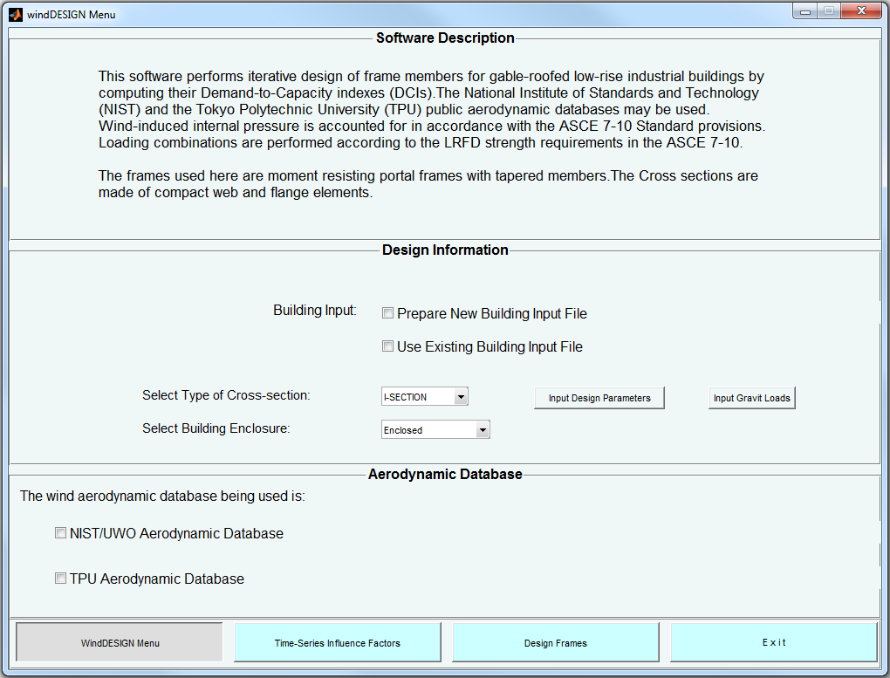

Figure 3: Frame Design Menu Page

### windDESIGN Menu

The *windDESIGN Menu* interface (Figure 3) includes the Software Description, Design Information and Aerodynamic Database panels. Within the *Design Information* panel an option to whether prepare new building input file or use existing building input file is provided. If the “Prepare New Building Input File” option is selected, an interface (*Enter Building Information*, Figure 4) will appear that enables preparing a building input file and saving it as comma-separated values (.csv) file format in a user selected folder destination. All the variables required in a building input file can be provided through this interface. The building input file can be further modified once it has been created and saved. The *Enter Building Information* interface has the following buttons:

***□ Input Building Dimensions***. This button opens the *Input Building Dimensions* dialog box (Figure 5), wherein the dimensions of the building to be analyzed and number of frames to be designed can be defined.

|  |  |
| --- | --- |
|  |  |
| Figure 4: Enter Building Information | Figure 5: Input Building Dimensions |

***□ Input Terrain Condition***. Roughness of the terrain surrounding the building can be specified in the dialog box shown in Figure 6. Two type of terrain roughness can be defined; “*Open\_Country*” terrain which corresponds to a roughness length of *z*0 = 0.03 m (0.1 ft), and “*Suburban*” terrain which corresponds to a roughness length of *z*0 = 0.3 m (1 ft).

|  |
| --- |
|  |
| Figure 6: Input Terrain Conditions |

***□ Input Frame Locations***. The along building-length location of each structural frame being designed is defined in the dialog box shown in Figure 7. For each frame of interest, its location and location of the neighboring frames are specified in the following manner; previous frame, frame of interest, subsequent frame as shown in Figure 8.

|  |  |
| --- | --- |
|  | C:\Users\fhabt003\Dropbox\DCI\DCI_JOURNAL PAPER\user_manual_figs\frame_locations 2.tif |
| Figure 7: Input Frame Locations | Figure 8: Definition of Frame Locations |

***□ Input Attachment Locations***. The locations at which girts and purlins are attached to the frames are defined by specifying the spacing between purlins and between girts in the dialog box shown in Figure 9. The locations of girts and purlins can be further edited by accessing the building input file once it has been saved.

|  |
| --- |
|  |
| Figure 9: Input Attachment Locations |

***□ Input Frame Supports***. Using the dialog box shown in Figure 10, the support conditions (either “*pinned*” or “*fixed*”) of the frames can be specified.

|  |
| --- |
|  |
| Figure 10: Input Frame Supports |

***□ Input Steel Design Parameters***. In this interface (Figure 11), the yield stress and modulus of elasticity of the steel material used are defined.

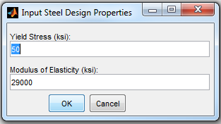

Figure 11: Input Frame Design Parameters

In the *Design Information* panel of the *windDESIGN Menu* interface, options for selecting and specifying; type of building enclosure (i.e. enclosed *Cpi* = +/- 0.18, partially enclosed *Cpi* = +/- 0.55, or open *Cpi* = 0), design parameters and gravity loads are also provided. Pressing the “Input Design Parameters” and “Input Gravity Loads” buttons open the dialog boxes shown in Figure 12 and Figure 13 respectively. In the dialog box shown in Figure 12, design wind speed (i.e. 3 sec gust wind speed at 33ft height according to the ASCE 7), section’s flange width, purlin or girt heights, section’s minimum web height, rafter division (i.e. ratio of RS 1 to Rafter length in Figure 23), maximum demand-to-capacity index (DCI), and preliminary arbitrary ratios of web heights are specified. The type of aerodynamic database to be used (i.e. NIST/UWO aerodynamic database or TPU aerodynamic database) is specified in the *Aerodynamic Database* panel located at the bottom of the *windDESIGN Menu* interface.

|  |  |
| --- | --- |
|  |  |
| Figure 12: Input Cross-Section Design Parameters | Figure 13: Input Gravity Loads |

### Computation of Time Histories of Responses

Pressing the “Time History of Responses” button at the bottom of the *windDESIGN Menu* interface (Figure 3), will open the graphical interface shown in Figure 14. Within this interface;

In the *Building Definition* panel, users can select a building input file that includes dimensions of the building and details of the preliminarily designed members. The location of frames within the building, internally computed influence coefficients, and preliminary frame designs can be displayed graphically by pressing the *Display* button. Interpolation Sensitivity Factors (sensitivity of interpolated time-histories to different building dimensions) can also be adjusted.

In the *Pressure Databases* panel, the folder containing the aerodynamic databases to be used in computing time-series of responses is selected. The contents of the selected folder will appear under the *Open Terrain:* and/or *Suburban Terrain:* listings, and the contents of an aerodynamic database can be displayed by pressing the *Display* button under the corresponding terrain. Calculation of time-histories of responses is commenced by pressing the *Compute Responses* buttons. When the *Compute Responses* button is pressed, users can activate in the *Select Response Computation Options* dialog box (Figure 15) options for (i) extending building directions by exploiting building symmetry, and (ii) reduction of aerodynamic pressure data volume by specifying a sampling rate factor defined as a ratio of the original sampling rate to a new sampling rate (Figure 16). Once the time-history of responses calculation is completed, the user will be prompted to confirm the name and folder destination of the file to be saved.

|  |  |
| --- | --- |
|  | |
| Figure 14: Computation of Time-histories of Responses GUI | |
| C:\Users\fhabt003\Dropbox\DCI\DCI_JOURNAL PAPER\user_manual_figs\Figure_15.PNG |  |
| Figure 15: Select Response Computation Options | Figure 16: Input Sampling Rate Reduction |

Once the wind-induced time history of responses are computed and saved, the listing of available response files in the *Time History of Responses* panel will be updated. Note that the responses computed here are for a wind speed of 1 ft/s at building eave height and are saved in *.mat* file format. The computed time histories of responses can be displayed graphically (Figure 17) by pressing the *Display* button under each listing. The user interface shown in Figure 17 also enables saving the time-history of response being displayed in a *.csv* file format. If results of responses from previous calculations are being used, the *Pressure Databases* panel can be skipped by directly selecting the folder containing the time-history of response files/files in the *Time History of Responses* panel. The *Select Response Computation Options* dialog box (Figure 15) can also be accessed using the *Response Computation Options* button in the *Time History of Responses* panel. In the time-history of responses listing, if more than one response output file is selected within one terrain, the *interpolate* button will be visible and interpolation of time-histories of responses can be performed.

|  |
| --- |
|  |
| Figure 17: Output of Time-series of Responses |

### Design of Frames

Pressing the *Design Frames* button at the bottom of the interfaces shown in Figure 3 and Figure 14 will open the *Design of Frames* interface (Figure 18). In this interface:

In the *Building Definition* panel, the building input file can be selected, and the preliminary frame design and the influence coefficients of each member can be displayed.

|  |
| --- |
|  |
| Figure 18: Design of Frames GUI |

In the *Wind Speeds and Design MRI* panel, an option to whether use wind speed from the ASCE 7 maps, or climatological databases is provided. If the ASCE 7 option is selected, the wind speed specified in the *Input cross-section design parameters* dialog box (Figure 12) is used in design. If the Climatological Databases option is selected, the left side of the panel will be active, and the folder containing the wind speed databases, the site location of the building being designed, and mean recurrence interval (MRI) can be selected. An option to whether use Hurricane or non-Hurricane winds is also provided. The non-Hurricane wind databases contain simulated directional wind speeds, average yearly storm recurrence rate, and period of years covered, for both thunderstorm and non-thunderstorm types of storm events.

In the *Design of Frame Members for Selected MRI* panel, the time-history of responses to be used in design can be selected. Three design cases are available: (1) “Perform Design” with no option, (2) “Perform Design” with the option of “Additional Design for Shear” option, and (3) “Perform Design” with the option of no iteration. The first case is for iterative design of members for axial loads and bending moments to obtain DCIPM less than but close to unity. The second case add to the first case the additional design of members for shear forces using DCIV. The final design case calculates without iterations the DCIPM and/or DCIV of preliminarily designed members provided by users. Once the design procedure is completed, the *Designed Frame Sections* interface shown in Figure 19 will appear. This interface displays the section dimensions as well as the DCIPM and DCIV results, and provides an option for saving the design results in a “.csv” file format.

|  |
| --- |
|  |
| Figure 19: Designed Frame Sections |

After the first design process is completed, the “Re-Design Frames” button in the *Design of Frame Members for Selected MRI* panel will be visible. If this button is pressed, the preliminary frame designs will be replaced by the new frame sections, new influence coefficients are calculated based on the new frame design, and the design process can be repeated again.

## 2.2 Building Input File

Building input files can be prepared manually or using the *Enter Building Information* interface shown in Figure 4. Once all the required inputs in the *Enter Building Information* interface are specified, pressing the *Save Building Input File* will create a *.csv* file format building input file (Figure 20). All the required keywords (keywords begin with asterisk) except \*UNITS (which defines the basic units used in the building input file) can be specified through *Enter Building Information* interface. The default units used are ft, lb, and ft/s for length, force and wind speed, respectively. The attachment locations and/or other inputs can be further modified by accessing the building input file shown in Figure 20. The definition of girt and purlin attachments is shown in Figure 21.

C:\Users\fhabt003\Dropbox\DCI\DCI_JOURNAL PAPER\user_manual_figs\input_file.tif

Figure 20: Sample Building Input File

|  |
| --- |
| C:\Users\fhabt003\Dropbox\DCI\DCI_JOURNAL PAPER\user_manual_figs\att_locations.JPG |
| Figure 21: Definition of Attachment Locations |

## 2.3 Design Output File

The *write design output* button at the bottom of the *Design Output* interface ( Figure 19) enables saving the design results in a *.csv* format output file. The output file additionally provides the building information of the building input file, including Building Dimensions, Terrain, Frame Locations, and Column Supports. A sample output file is shown in Figure 22, and as in the building input file the keywords (key parameters) are indicated by an asterisk.

***\*ENCLOUSRE.*** The type of building opening enclosure used is specified.

***\*FRAME\_DESIGN\_PARAMETERS.*** Here the following parameters which were used in performing the design calculations are specified; (i) ASCE 7 based design wind speed (3 sec gust at 33 ft.), which is used in the preliminary frame design, and also in performing final designs if selected by user, (ii) the minimum web height used in designing the cross-section, (iii) yield strength of the steel material, (iv) modulus of elasticity of the steel material, (v) flange width, (vi) purlin/girt height, (vii) dead load, (viii) roof live load (ix) rain load, and (x) maximum demand-to-capacity index (DCI) used in design.

***\*FRAME SECTIONS DESIGNED USING ASCE 7-10***. Preliminary frame design is performed using wind loading from the ASCE 7-10 (Chapter 28). The preliminary section properties for 9 cross-sections (Figure 23) across each frame considered are provided under this heading. For each cross-section, the flange width and thickness, web height and thickness, section area, the strong (x-x) and weak (y-y) axes moment of inertias (I) and section modulus (S) are displayed.

***\*AERODYNAMIC DATABASE USED***. The source of aerodynamic database used to calculate the time-histories of responses is specified. “National Institute Standards and Technology (NIST)” or “Tokyo Polytechnic University (TPU)” will be displayed depending on the public database used.

***\*DESIGN WIND SPEED.*** Type of wind speed used in performing frame design calculation using the DAD method is specified. “Wind Speed from ASCE 7”, “Hurricane Wind Speeds”, or “Non-Hurricane Wind Speeds” will be displayed under this keyword depending on the type of winds speed used.

|  |
| --- |
| C:\Users\fhabt003\Dropbox\DCI\DCI_JOURNAL PAPER\user_manual_figs\output3.png |
| Figure 22: Sample Design Output File |

\****FRAME SECTIONS DESIGNED USING Database-Assisted Design.*** The final frame design using Database-Assisted Design methodology is provided herein. Similar to the results of frame designs using ASCE 7-10, section dimensions of 9 cross-sections across each frame are given. The final design results also include the final demand-to-capacity indexes, DCIPM and DCIV. .

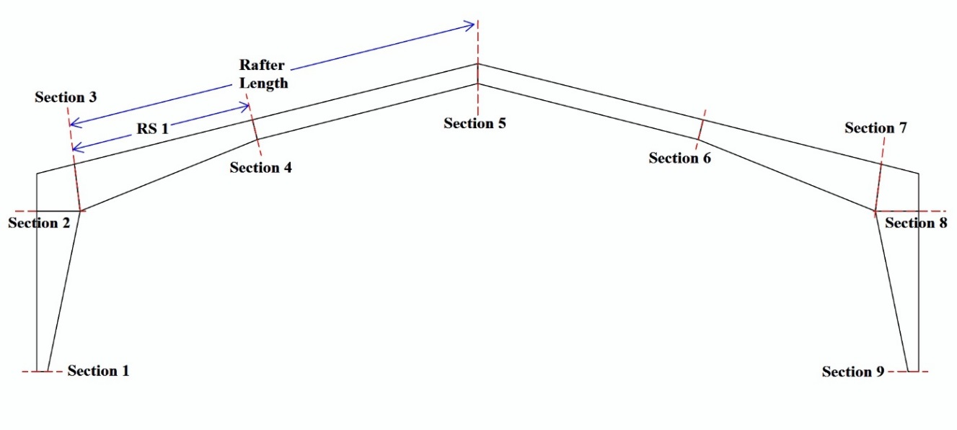

Figure : Definition of Sections in the Design Output File

## 2.4 Design Example

Consider a gable roofed industrial low-rise building. The building is 52.5 ft (16 m) in width (B), 78.7 ft (24 m) in length (L), 26.2 ft (8 m) in height (H), and has a roof slope of 14.0 deg (i.e. roof rise of 6.54 ft (2 m)). It has web-tapered moment-resisting frames spaced at 17.5 ft (5.33 m), and it is required to design the 2nd and 3rd frames. The building is assumed to be located in Miami, FL. Note that the software requires the following four main inputs (i) A building input file, (ii) design parameters and static loads, (iii) aerodynamic database (NIST or TPU database), and (iv) climatological database and design wind speed. This design example section provides users with a step-by-step explanations of the inputs required for executing the windDESIGN program.

***windDESIGN Menu page***

In this example a new building input file is created. The interface for creating a new building input file can be displayed by selecting the “Prepare New Building Input File” option in the *windDESIGN Menu* page (Figure 3). The information shown in Table 1 is then entered. The *SAVE BUILDING INPUT FILE* button (Figure 4) creates an input building file named “*BLDG W=52.5, L=78.7, H=26.2, R=6.6, Suburban.csv*” for later use. Once the input building file has been saved, the “Use Existing Building Input File” option is selected.

Table : Enter Building Information

|  |  |  |
| --- | --- | --- |
| Input Building Dimensions | Building Width, B (ft) : | 52.50 |
| Building Length, L (ft) : | 78.70 |
| Building Height, H (ft) : | 26.2 |
| Roof Rise, R (ft) : | 6.56 |
| Number of Frames to be designed : | 2 |
| Input Terrain Conditions : | | Suburban |
| Input Frame Locations : | | 0 17.5 35 |
| 17.5 35 52.5 |
| Input Attachment Locations | Spacing between girts : | 3 |
| Spacing between purlins : | 3 |
| Input Frame Supports | Frame support – right column : | Pinned |
| Frame support – left column : | Pinned |
| Input Steel Design Properties | Yield Stress (ksi) : | 50 |
| Modulus of Elasticity (ksi) : | 29000 |

The next step is to specify the building enclosure, design parameters and gravity loads. In this example the default building enclosure *Enclosed* is used, and the information shown in Table 2 and Table 3 are entered into the *Input Design Parameters* and *Input Gravity Loads* dialog boxes respectively.

Table : Input Design Parameters

|  |  |  |
| --- | --- | --- |
| Design Wind Speed (ft/s) : | | 250 |
| Flange Width (ft.) : | | 0.33 |
| Purlin / Grit Height (ft.) : | | 0.70833 |
| Minimum web height (ft.) : | | 0.67 |
| Segment 2 – fractional length (0 to 1) : | | 0.4 |
| Maximum DCI : | | 1 |
| Preliminary Ratios of Web Heights | Knee to Column Base : | 3 |
| Pinch to Column Base : | 2 |
| Ridge to Column Base : | 3 |

Table : Input Gravity Loads

|  |  |
| --- | --- |
| Superimposed Dead Load (psf) : | 2 |
| Roof Live Load (psf): | 20 |
| Rain Load (psf): | 5 |

In the *Aerodynamic Database* panel of the *windDESIGN Menu* page, the *TPU Aerodynamic Database* option is selected. Recall that the NIST/UWO aerodynamic datasets are in *.HDF* file formats while the TPU aerodynamic files are in *.mat* file formats, the windDESIGN software can read both types of files but the appropriate database should be specified in the *Aerodynamic Database* panel.

***Computation of Time histories of Responses page***

In the *Building Definition* panel, the *BLDG W=52.5, L=78.7, H=26.2, R=6.6, Suburban.csv* building file is selected. This step (i) reads the input building file, (ii) performs design of frames sections using wind load from the ASCE 7-10, Chapter 28 (those sections serve as the preliminary designs), and (iii) creates a data-structure named *bldg\_struct* which contains building input information, design parameters, gravity loads, and preliminary section designs. The contents of data-structure *bldg\_struct* are shown in Table A1. The preliminary section designs can be viewed by pressing the display button in the Building Definition panel.

A folder containing aerodynamic datasets for the building being designed is selected in the *Pressure Databases* panel. (For this example they can be downloaded from <http://www.wind.arch.t-kougei.ac.jp/info_center/windpressure/grouplowrise/mainpage.html> ).

In this example, time histories of responses are computed for wind directions of 270, 300, 330 and 360 degrees (orientation of wind direction is shown in Figure 8). The “use symmetry to extend wind direction range” option is selected and the sampling rate factor of 2 is used for faster computation. Once the calculation is completed, a file named *DIF W=52.5, L=78.7, H=26.2, R=6.6, Suburban.mat* is created and saved. This file consists of a data-structure named *TIF\_struct* which contains the computed time-histories of responses and other variables (Table A2).

***Design of Frames page***

In this example hurricane wind speeds are used. The building is assumed to be located in Miami, FL (Milepost 1450) and design is performed for Mean Recurrence Interval (MRI) of 700 years. In the Wind Speeds and Design MRI panel, the climatological databases option is selected, and milepost 1450 is selected after browsing to the folder containing the hurricane wind speed datasets.

In the *Design of Frame Members for Selected MRI* panel, the appropriate TIF file is selected from “suburban” time history of responses listing, and the “Design for Shear” option is also selected. Pressing the “Perform Design” button commences the design calculations, and once the calculations are completed a data-structure with the designed frame sections and their DCI values named DCI\_struct is created. The contents of DCI\_struct are shown in Table A3.

The final results of section designs with their DCIs are shown in Table 4. The section numbers are shown in Figure 23, sections 6 to 9 are omitted from Table 4 because of frame symmetry.

Table : Output of Designed Frame Sections

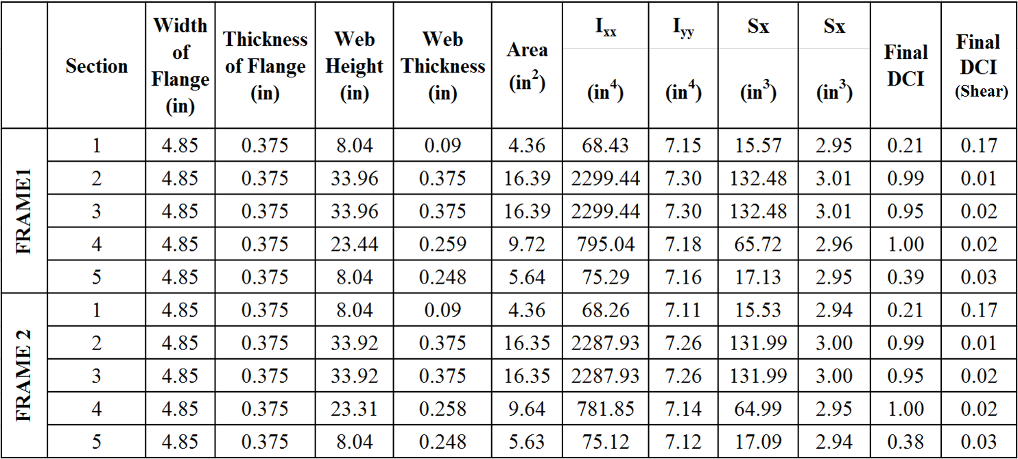

## 

# APPENDIX A

In this appendix, descriptions of the variables existing in the *bldg\_struct*, *TIF\_struct* and *DCI\_struct* data-structures are provided. (‘\*’ denotes variable description and ‘–’ denotes values of the variable for the design example provided above).

Table A: Variables of the *bldg\_struct* Data-structure

|  |  |
| --- | --- |
| ***d0*** | \*a vector with the building’s geometric dimensions, [B, L, H, R] in ft.   * [52.5, 78.7, 26.2, 6.56] |
| ***Filename*** | \* the building input filename   * ‘BLDG W=52.5,L=78.7,H=26.2,R=6.6,Suburban.csv’ |
| ***pathname*** | \* pathname of the building input file   * ‘C:\....’ |
| ***length\_units*** | \*length unit   * ‘ft’ |
| ***force\_units*** | \*force unit   * ‘lb’ |
| ***ws\_units*** | \*wind speed unit   * ‘ft/s’ |
| ***terrain*** | \* terrain surrounding the building being designed   * ‘Suburban’ |
| ***z0*** | \*terrain roughness in feet   * 0.984 |
| ***frame\_coords*** | \*Nf x 3 matrix describing the location of the frames being designed, (Nf represents number of frames being designed) $\left[\begin{matrix}0 & 17.5 & 35 \\ 17.5 & 35 & 52.5\end{matrix}\right]$ |
| ***attach\_points*** | \*Na x 2 matrix describing the location of each purlin/girt on the frame, (Na represents number of attachments) - [face number, location along face] $\left[\begin{matrix}1 & 0 \\ 1 & 4.25 \\ : & :\end{matrix}\right]$ |
| ***column support*** | \*support system of the left and right columns   * [“pinned”, “pinned”] |
| ***frame\_design\_***  ***parameters*** | \*vector with the user specified design parameters and static loads   * [design wind speed, minimum web height, yield strength, elasticity, flange width, purlin/girt height, dead load, roof live load, rain load, maximum DCI] |
| ***section\_type*** | \*the type of frame cross-section used   * ‘I-Section’ |
| ***enclosure*** | \*the type of building enclosure   * ‘Enclosed’ |
| ***frame\_segments*** | \*6 x 10 matrix of arbitrary pre-preliminary frame section dimensions. The 6 rows represent the 6 frame segments shown in Figure A1, and the columns represent in order: face number, length ratio, flange width at segment start, flange thickness at segment start, web height at segment start, web height at segment end, web thickness at segment start, flange width at segment end, flange thickness at segment end, and web thickness at segment end.  C:\Users\fhabt003\Documents\user manual\frame_sections3_Fotor.jpg  Figure A1: Frame Faces and Segments   * frame\_segments:   C:\Users\fhabt003\Desktop\mat.png |
| ***b2\_max*** | \*maximum B2 factor (note that B2 is a factor used to estimate the ratio of the second-order analysis drift to its first-order analysis counterpart)   * 1.0021 |
| ***resp\_names*** | \* a vector with all the names of the frame responses   * [Axial load at column base, Shear at column base, …] |
| ***resp\_units*** | \* a vector with all the units of the responses specified in variable resp\_names variable   * [lb., lb., lb.ft., lb., …] |
| ***frame\_resp*** | \*a matrix specifying the location and numerical notation of each response (i.e. 1-Axial, 2-Shear, and 3-moment).   * [Face number, location along face, response numerical notation] |
| ***ASCE\_designs*** | \* 3 x 10 x Nf, matrix of frame sections designed using wind load from ASCE 7-10, chapter 28. Nf represents the number of frames designed. The rows represent segments 1 to 3 (Figure A1), and the column arrangement is similar to those used in the frame\_segments variable.   * ASCE\_designs:   C:\Users\fhabt003\Desktop\mat2.png |
| ***ASCE\_dci*** | \*3 x 3 x Nf, matrix of Demand-to-Capacity indexes (DCI) of the frame sections in the ASCE\_designs variable. The rows represent the frame segments, and the columns represent in order: segment start, segment mid, and segment end.   * ASCE\_dci: |
| ***ASCE\_s\_dci*** | \*3 x 3 x Nf, matrix of Demand-to-Capacity Indexes for shear, (DCIV) of the sections in the ASCE\_designs variable. The rows represent the frame segments, and the columns represent in order: segment start, segment mid, and segment end.   * ASCE\_s\_dci: |

Besides variables; *d0*, *resp\_names*, *resp\_units*, *length\_units*, *force\_units*, *ws\_units*, *enclosure*, *terrain*, *frame\_coords*, and *attach\_pts* which also exist in the bldg*\_struct* data-structure, *TIF\_struct* also includes the variables shown in Table A2.

Table A: Variables of *TIF\_struct* Data-structure

|  |  |
| --- | --- |
| ***d*** | \*a vector with the aerodynamic model’s geometric dimensions [B, L, H, R] in ft.   * [52.5, 78.7, 26.2, 6.6] |
| ***TIF\_filename*** | \*filename of the ‘.mat’ file containing the TIF\_struct data structure   * ‘DIF W=52.5,L=78.7,H=26.2,R=6.6, Suburban.mat’ |
| ***theta\_all*** | \*a vector specifying all the wind directions considered, in deg.   * [0; 30; 60; 90; 0; 330; 300; 270;…] |
| ***theta*** | \*a vector specifying the unique wind directions considered (if building symmetry is not exploited theta would be equal to theta\_all), in deg.   * [0; 30; 60; 90; 120; 150; 180; 210; 240; 270; 300; 330] |
| ***TS*** | \*Nf x Nt matrix, where Nf represents the number of frames being designed and Nt represents the number of unique wind direction (i.e. from variable theta). Each element in matrix TS consists of time-histories of responses for a wind speed of 1ft/s at eave height. For instance TS [2, 3] consists of time-histories responses for the second frame at the third wind direction.  In this example, TS is a 2 x 12 matrix, and TS [2, 3] consists of time-histories of responses for the second frame and wind direction of 60 deg. |
| ***TS\_Dr*** | \*Similar in structure to variable TS, but each element in TS\_Dr consists of time-history of frame sway for a wind speed of 1ft/s at eave height |
| ***Pestory*** | \*Nf x Nt matrix, each element in variable Pestory represents frame’s story critical buckling strength. |
| ***ws*** | \*wind speed conversion factor,  [hourly wind speed at eave height, 3sec gust at 10 m over open terrain]   * [1, 2.2719] |

The *DCI\_struct* data-structure contains the following variables; *d0, d*, *resp\_names*, *resp\_units*, *length\_units*, *force\_units*, *ws\_units*, *enclosure*, *terrain*, *z0*, *frame\_coords*, and *attach\_pts* which also exist in data structures *bldg\_struct* and/or *TIF\_struct* it also includes the variables shown in Table A3.

Table A: Variables of the *DCI\_struct* Data-structure

|  |  |
| --- | --- |
| ***Axial\_TS*** | \*Nf x Nt matrix, where Nf represent number of frames being designed and Nt represents number of wind direction (variable theta). Each element in matrix Axial\_TS consists of time-history of axial responses at the start, mid, and end of frame segments 1 to 3 for a wind speed of 1ft/s at eave height. For instance Axial\_TS [2, 3] consists of time-history of axial responses for the second frame at the third wind direction.   * In this example, Axial\_TS is a 2 x 12 matrix, and Axial\_TS [2, 3] consists of time-history of axial responses for the second frame and wind direction of 60 deg. |
| ***BM\_TS*** | \*similar in structure to variable Axial\_TS but variable BM\_TS consists of time histories of bending moments |
| ***Shear\_TS*** | \*similar in structure to variable Axial\_TS but variable Shear\_TS consists of time histories of shear load |
| ***V\_H*** | \*a vector or matrix containing wind speeds used in design   * In this example, V\_H is a 999 x 16 matrix of hurricane wind speeds from milepost 1450 (Miami, FL) |
| ***mu*** | \*hurricane or storm recurrence rate. This variable is important when climatological databases are used   * 0.56 |
| ***orientations*** | \*a vector consisting the building orientation considered, in deg.   * [0, 15, 30, …] |
| ***MRI\_list*** | \*design mean recurrence interval (MRI), in years   * 700 |
| ***fr\_designed*** | \* 3 x 10 x Nf, matrix of the final designed frame sections. The rows represent segments 1 to 3 (Figure A1), and the columns represent the parameters specified in the columns of the frame\_segments (BLDG\_struct) variable.   * fr\_designed:   C:\Users\fhabt003\Desktop\mat3.png |
| ***DCI\_FINAL*** | \*3 x 3 x Nf, matrix of DCIs of the frame sections in the fr\_designed variable. The rows represent the frame segments, and the columns represent in order: segment start, segment mid, and segment end.   * DCI\_FINAL: |
| ***DCI\_S\_FINAL*** | \*3 x 3 x Nf, matrix of DCIVs for shear of the sections in the fr\_designed variable. The rows represent the frame segments, and the columns represent in order: segment start, segment mid, and segment end.   * In this example, DCI\_S\_FINAL: |